Vestry Announces Our New Priest-in-Charge
From: John Priscantelli, Senior Warden and Durrie Golding, Co-Chair Search Committee

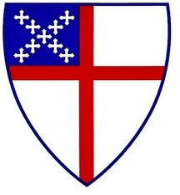
The Vestry and Search Committee are pleased to announce the calling of our new Priest-in-Charge for St. Mary’s: the Reverend Alan Christopher Lee. Father Chris comes to us from Grace Church in Brooklyn Heights, NY where he served for the last two years as their Assistant to the Rector for Youth, Young Adult and Family Ministries.

Chris, his wife, and their two teenage sons are excited to be moving here to Chappaqua and joining our parish family. The boys, having grown up in the city, were especially thrilled to see the baseball field right across the street from the Church when they all came to visit.

Below is a brief bio that he sent us, so we may get to know him and his family a little better before they join us. They will be moving into the Rectory starting the week of October 3rd. Chris will celebrate his first Mass with us on Sunday, October 9, 2022.
Please come by if you are able so we can give him a warm St. Mary’s welcome!

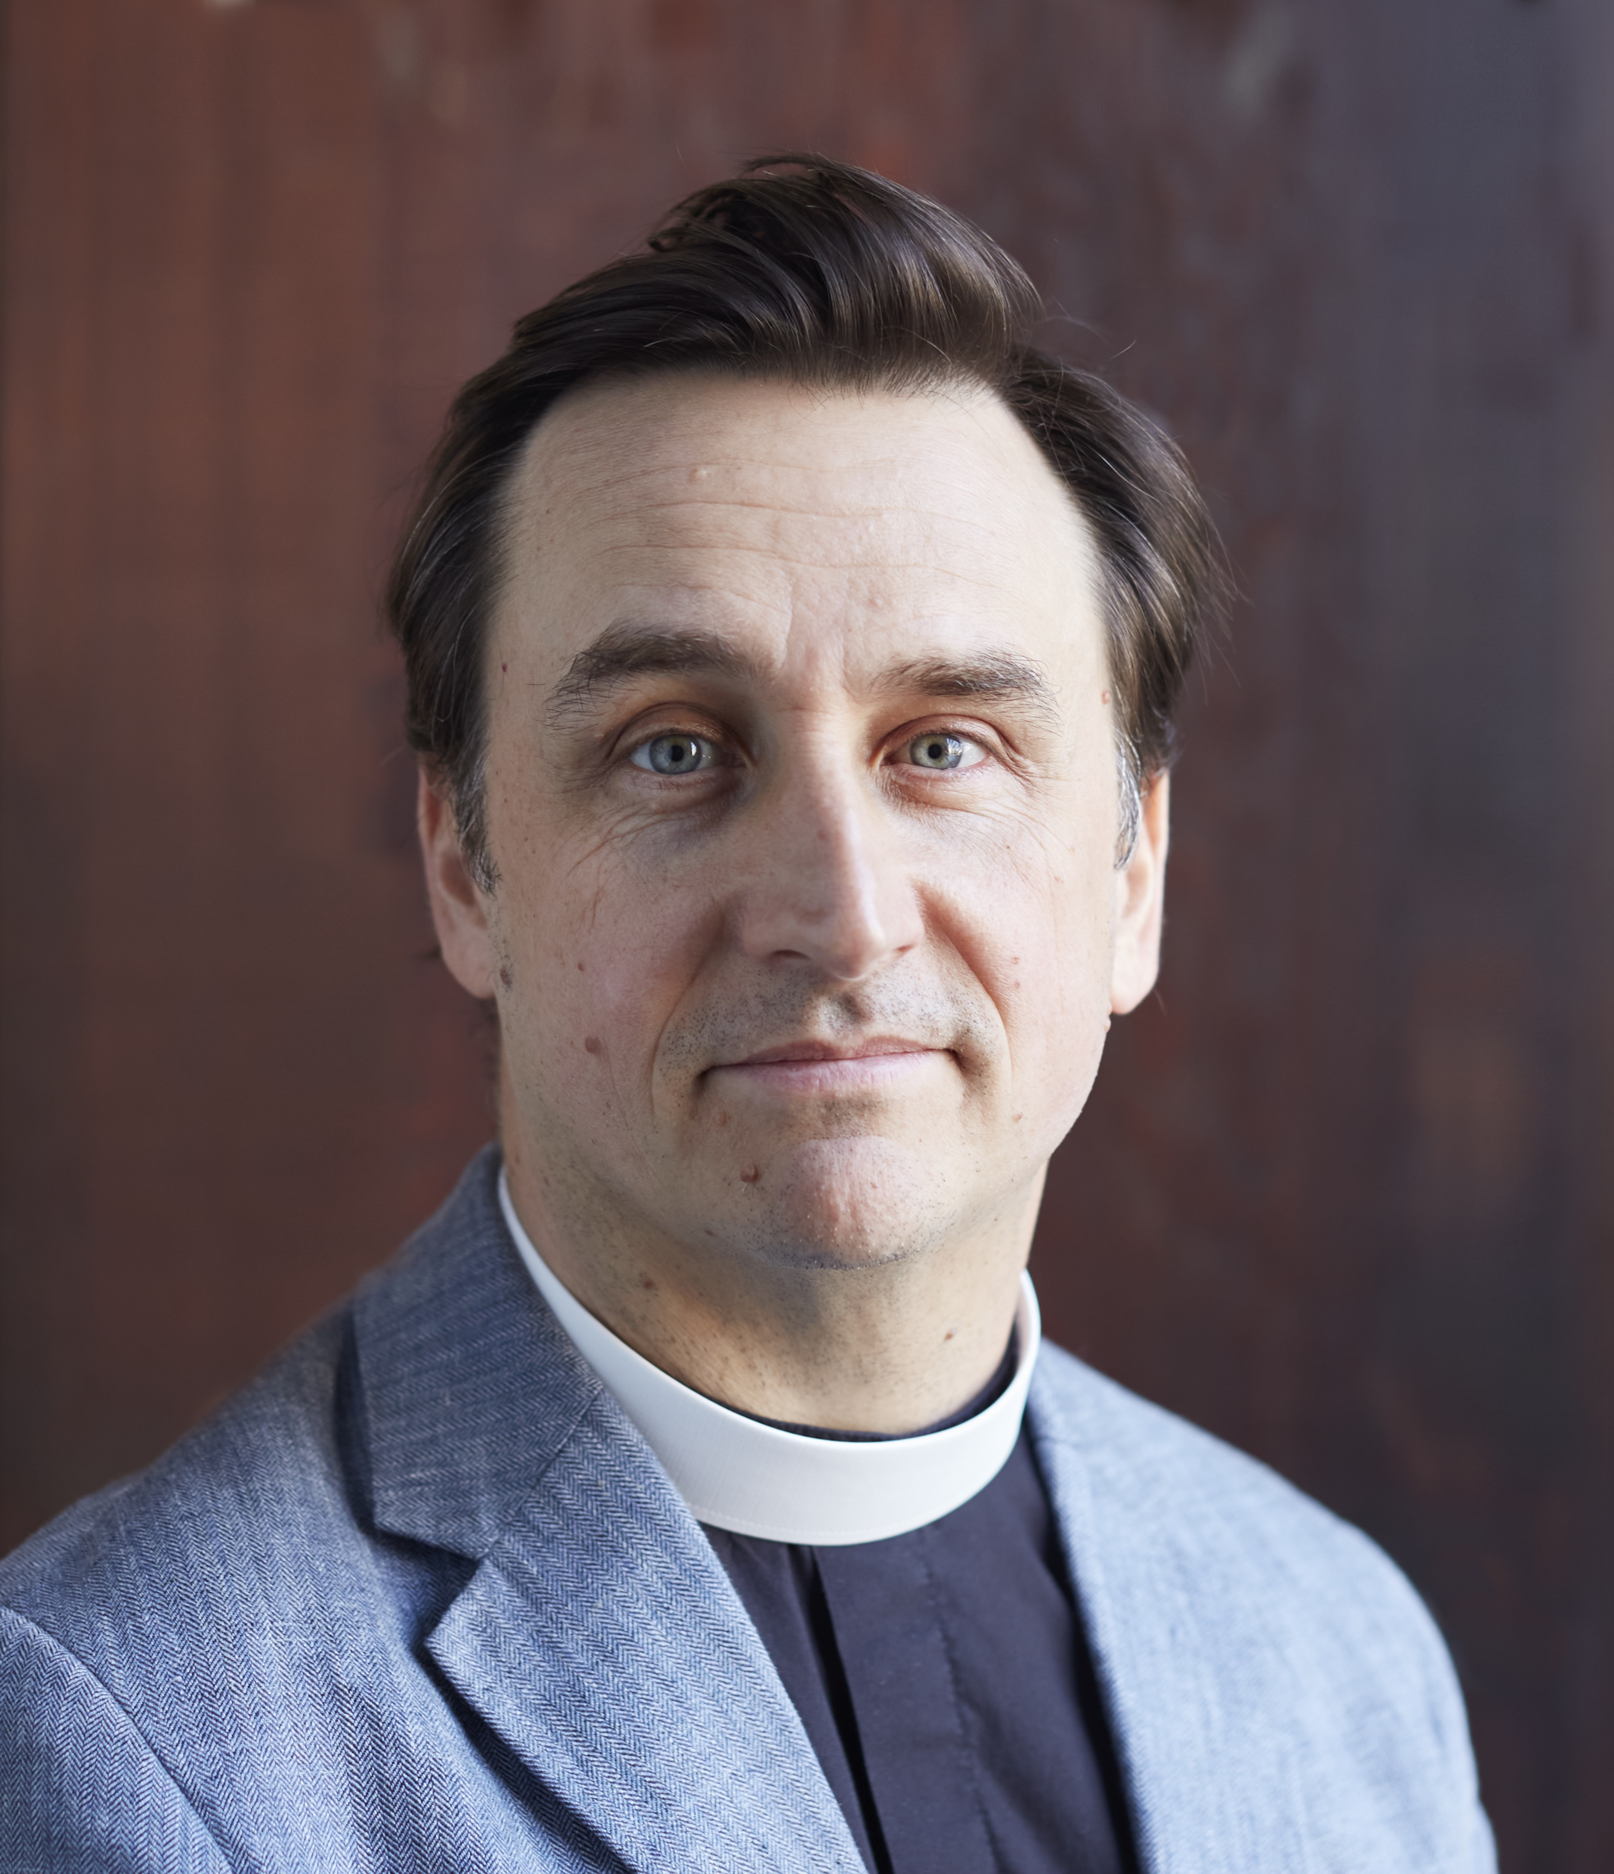
From the website of Grace Church in Brooklyn Heights, NY:
The Rev. Alan Christopher Lee is our Assistant to the Rector for Youth, Young Adult, and Family Ministries. Chris is a cradle Episcopalian from Charlotte, NC, an alumnus of UNC-Chapel Hill, and received his M.Div. from the General Theological Seminary in May 2020. He has lived in Brooklyn since 1995, and worked as a musician and as a journalist before discerning a call to ordained ministry. Chris’ passions in ministry include Christian formation for all ages, the church’s role in racial reconciliation, and exploring the richness of Anglican liturgy and music. He also enjoys reading, playing guitar, and coaching youth sports. Chris is married to Julie Bleha, and they are the parents of Thaddeus and Callum.

Of course we would be remiss if we didn’t express the Vestry’s appreciation for all that the Search Committee has been doing (and done) on our behalf over these past several months. Their tireless efforts and thoughtful discussions and deliberations have led us to where we are today – making this wonderful announcement – and in an amazingly timely manner. THANK YOU!

And to Mother Margie – thank you is not enough. She graciously agreed to step in this spring and be our Interim Priest when our spiritual path was unsure. Her wisdom, guidance and pastoral care of each and every one of us has provided that rock and foundation we needed during this transition time. Mother Margie’s final Mass with us will be on Sunday, September 25th. Mother Margie, we will miss you, but as you will not be that far away, come back and join us anytime.

